**Natural Wooden Scalloped Floating Wall Shelves**

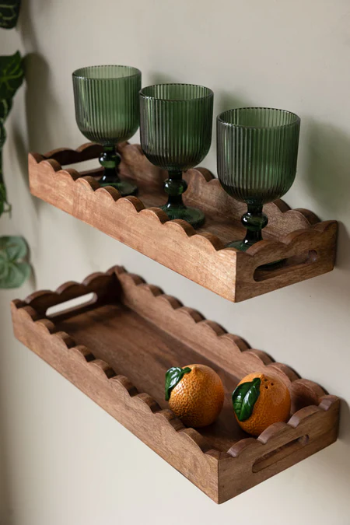Natural wooden scalloped floating wall shelves offer a charming and rustic touch to any interior space. Crafted from wood with a natural finish, these shelves showcase delicate scalloped edges that enhance their aesthetic appeal. Perfect for showcasing candles, small plants, or decorative items, they bring warmth and texture to the room while maintaining a clean and minimalist look. These versatile shelves seamlessly blend into farmhouse, bohemian, or contemporary decor, adding both functionality and timeless beauty.